AI Bias Disclosure: A Must-Have for Responsible AI

In today's world, AI is rapidly becoming an integral part of our lives. However, the increasing reliance on AI systems has also brought to light the potential for bias to creep into these models. As AI developers and users, it's crucial to address these biases head-on and ensure that AI is used ethically and responsibly. One critical step in this process is effective disclosure of AI model biases to stakeholders.

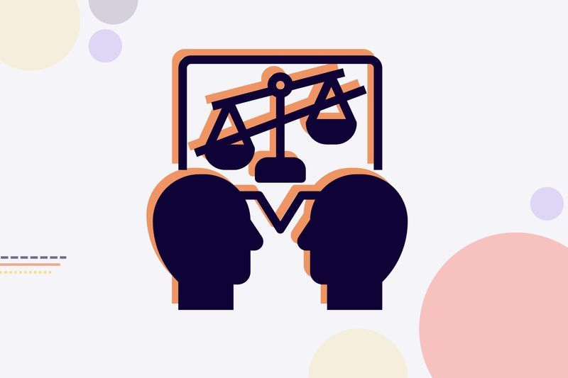

(Source: [AI Bias - What Is It and How to Avoid It? (levity.ai)](https://levity.ai/blog/ai-bias-how-to-avoid))

### What is AI Bias?

AI bias refers to the unfair or inaccurate treatment of individuals or groups based on their race, gender, age, religion, or other characteristics. It can occur when AI models are trained on data that is biased or incomplete.

### Why is Bias Disclosure Important?

* **Builds Trust:** Transparent disclosure of AI biases helps to build trust between AI developers and stakeholders.
* **Ensures Fairness:** By understanding the biases in AI models, stakeholders can take steps to ensure that the models are used fairly and equitably.
* **Promotes Accountability:** Disclosing biases helps to hold AI developers accountable for the impact of their models.

### Effective Strategies for Disclosing AI Model Biases

1. **Document and Disclose All Known Biases:** Maintain a comprehensive registry of identified biases, including their nature, potential impact, and mitigation strategies. Use clear and concise language to explain these biases to stakeholders, avoiding technical jargon.
2. **Engage in Ongoing Dialogue:** Foster open communication with stakeholders to gather feedback on identified biases and collaborate on mitigation strategies. Be transparent about the limitations of these strategies and acknowledge that it may not be possible to completely eliminate all biases.
3. **Provide Regular Updates:** Keep stakeholders informed about the progress made in addressing biases and be honest about any challenges encountered. Invite feedback on the disclosure process to continually improve it.
4. **Involve Diverse Stakeholders:** Ensure that the disclosure process involves a diverse group of stakeholders to represent different perspectives and experiences.
5. **Consider the Impact on Different Groups:** Assess how biases may disproportionately affect certain groups of people and take steps to mitigate these disparities.
6. **Provide Resources for Further Learning:** Share resources that can help stakeholders learn more about AI bias and its implications.
7. **Be Proactive:** Continuously monitor AI models for new biases and take proactive steps to address them as they arise.

### Conclusion

Effective disclosure of AI model biases is essential for building trust, ensuring fairness, and promoting accountability in AI development and use. By following the strategies outlined in this blog, AI developers can take a significant step towards creating AI systems that are ethical, responsible, and beneficial to society.